Test 8: numplants = 167 target_size = (224,224) batch*size = 72 epochs = 200 Model: "sequential" __* Layer (type) Output Shape Param #  
================================================================= resnet101 (Model) (None, None, None, 2048) 42658176  
_ global_average*pooling2d (Gl (None, 2048) 0  
__* dense (Dense) (None, 2048) 4196352  
_ dense*1 (Dense) (None, 1024) 2098176  
__* dense*2 (Dense) (None, 512) 524800  
__* dense_3 (Dense) (None, 167) 85671  
================================================================= Total params: 49,563,175 Trainable params: 49,457,831 Non-trainable params: 105,344 72/72 [==============================] - 171s 2s/step - loss: 1.3268 - accuracy: 0.7135 test acc: 0.7135417

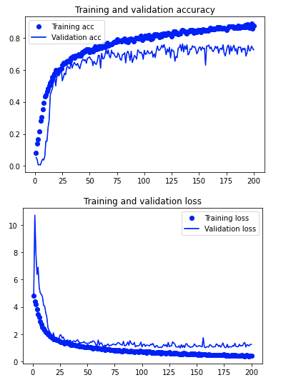

Conclusion: Need a lot more memory to work with EfficientNetTop of Form